Shabbos Stories for
Yom tov pesach 5780
Volume 11, Issue 31 15-22 Nissan/ April 9-16, 2020
Printed L’illuy nishmas Nechama bas R’ Noach, a”h

For a free subscription, please forward your request to keren18@juno.com

A Combat Officer’s Passover In the Sands of Kuwait
By Nicole Bauke

Capt. Sanford Cohen counts down the end of his deployment in Kuwait by the number of Shabbats, rather than days.

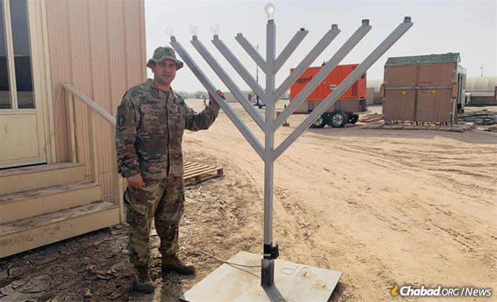
Capt. Sanford Cohen in Kuwait with the menorah he obtained with the help of the Aleph Institute.
“It’s a lot more manageable,” said Cohen, 38, from Staten Island, N.Y. “I’m going to quote one of my ... soldiers on this: The Friday-night service is what he looks forward to in his week. It completes his week. It pains him when he can’t make it. It pains him.”
There is not a single Jewish chaplain at Camp Buehring Army Base—let alone in all of Kuwait—but despite this, Cohen’s religious observance has remained at the forefront of his priorities, so much so that he has become a volunteer lay leader endorsed by the Jewish Welfare Board.
“When you don’t know if the bullet that’s being fired has your name on it, the ability to do more mitzvot ... takes precedence over other projects,” said Cohen.
Counting down by Shabbats is easier for his three sons—ages 3, 6 and 9—to grasp, too. While they only have a chance to speak to him on Sundays due to the time change and differing schedules, they always tell him what they did over Shabbat.
“It’s something they get,” said Cohen. “I’ll take an article from Chabad.org or Aish [on the week’s parsha], and send it to my oldest son ... with, ‘hey, I thought you’d like this ... .’ He reads it, and they discuss it on Friday night.”
And for Cohen, a Brigade Ammunition Officer of the 35th Combat Aviation Brigade, the end of Passover marks his 40th (and last) Shabbat of his nine-month deployment. But for now, he is busy preparing for and organizing Passover on base, expecting about 20 people to attend the Seders.
“I’m not going to be with my family, but I’m going to be with my Army family,” said Cohen, whose family back in the States will be spending the holiday with his in-laws at a Chabad-run resort hotel in South California.
As a lay leader, Cohen orders kosher MREs (shelf-stable Meals Ready to Eat), leads Friday-night services and organizes holiday celebrations for his fellow troops. Their Passover supplies would not be the same without the support of Jewish organizations such as the Aleph Institute, which provide items that cannot be ordered through the military.
“The only way to have a connection is through organizations like Aleph Institute and Kosher Troops. They are what keeps us connected [when] there is no synagogue, there is no kosher restaurant,” said Cohen.
The Aleph Institute sends religious materials throughout the year—Torah scrolls, menorahs, hamantashen, military camouflage siddurim (prayer books) and other Jewish books. For Passover, they send whatever is needed to complete a seder meal, such as Haggadahs, seder plates, charoset and shmurah matzah, benefiting approximately 1,000 soldiers on about 60 bases worldwide.
“This campaign was started by the Rebbe [Rabbi Menachem M. Schneerson, of righteous memory] in 1941 or ‘42, and he oversaw it personally,” said Rabbi Menachem Katz, director of military and prison outreach at the Aleph Institute. “It’s something that goes back hundreds of years—back to every Lubavitcher Rebbe in Russia, where they took care of the Russian Jewish soldiers in the Russian Army and made sure they had matzah for Pesach and so on.”

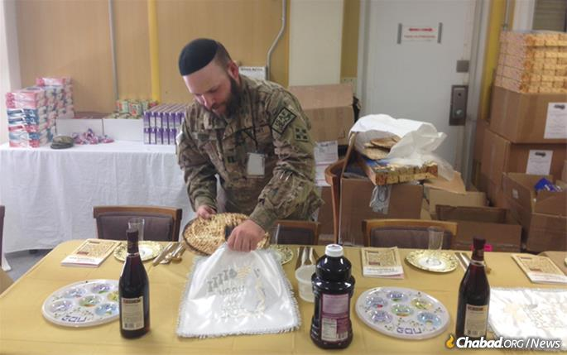
Capt. Mendy Stern, chaplain for the 312th Military Intelligence Battalion, sets up for a Passover seder.

The Aleph Institute also helps connect Jewish troops with the visiting Jewish chaplain so that more Jews are able to participate in holiday celebrations and religious observations, according to Capt. Mendy Stern, chaplain for the 312th Military Intelligence Battalion.
Stern, stationed at Fort Sam Houston in San Antonio, Tex., is preparing for deployment to serve as the rabbi for troops in Afghanistan during Passover. This will be his second Passover deployment and his sixth deployment overall.
“This opportunity to serve those who serve our great country is an absolute honor and privilege,” wrote Stern over email. “Since joining the Army, I’ve encountered many Jewish troops whose lives were touched by the mere presence of a Jewish chaplain or the opportunity to observe a mitzvah in an otherwise Jewish religious desert.”

Rotate Holiday Coverage Among Locations
His Passover preparations are complicated, to say the least. Usually, chaplains on the ground, who are usually not Jewish, request kosher-for-Passover MREs (Meals Ready to Eat) and “Seder Kits,” which provide the basic items, according to Stern. Everything must be arranged and shipped far in advance, and, traditionally, more people than expected tend to show up. During his previous Passover deployment, more than 60 Jews attended the Seders.
“As there are so few Jewish chaplains, we must rely heavily on the chaplains on the ground to advertise and help spread the word of the upcoming services,” wrote Stern. “We rotate for holiday coverage to locations where there is no Jewish chaplain. ... We arrive a few days before Pesach, and we set up the Seder, while still visiting the troops, providing counsel and [offering] support to the mission.”
The lack of Jewish chaplains is a real issue for Cohen, who wishes that more rabbis would bring their religious outreach to the U.S. military. He became a lay leader after traveling two-and-a-half hours to Camp Arifjan last Fall for Rosh Hashanah—the closest location for prayer services—forcing him to miss several days of work at his own base. There are “dozens” of chaplains at Camp Buehring, but no rabbis.
“There aren’t enough rabbis as chaplains in the military, so guys like me have to step up,” said Cohen. “This is the place—the Army, the military—to do the most good, the most Kiddush Hashem, not just for the Jews but the non-Jews.”
Even though there are about 5,000 Jewish-affiliating soldiers in the military, Katz estimates, there are only 12 active-duty Jewish chaplains in the Army, and less than 50 in the entire military. Where there isn’t a rabbi, lay leaders like Cohen fill the role as best they can. But both Stern and Cohen agree: It may be more complicated than a holiday at home, but it’s a shlichus that is well worth it.
“On one hand, there’s a bittersweet feeling of being away from family during the holiday, having to imagine the children asking the ‘Mah Nishtanah’ [‘Four Questions’] and celebrating thousands of miles away from home. On the other hand, the feeling that I’m embarking on a shlichus [emissary] mission, to celebrate Passover with servicemen and women who are far from home ... it’s an adventure which I wouldn’t pass up.”

Reprinted from the Pesach 5779 email of Chabad.Org Magazine.

Why Do We Make Kiddush Right Away at the Seder?

One year, upon arriving home from shul on the first night of Pesach, the Shpoler Zeida’s son announced in the customary niggun, “Kadesh: Ven der tatte kumt aheim fun shul macht er bald kiddush” (Kadesh: When father comes home from shul on Pesach, he recites Kiddush right away).
The Shpoler Zeide asked him why, but the boy replied that this was all his melamed had taught him. The Shpoler Zeide then told him the explanation that needs to be added, “kdei di kinder zollen nit ainshloffen un freggen di Mah Nishtana” (so that the children will not fall asleep and will ask the four questions).”
At the Yom Tov seuda the next day, the Shpoler Zeide asked his son’s melamed why he had not taught the reason for Kadesh, as this has been the minhag since the distant past.
“I didn’t think it was necessary to teach this to small children, especially since this reason isn’t so important, for making Kiddush early applies to everyone, even if there are no small children at home.”
The Shpoler Zeide strongly protested, “How dare you say that this reason is unimportant? Are you wiser than the melamdim of previous generations? You simply don’t begin to understand why they taught in this way. Don’t ever change their minhagim according to what you consider logical!”
The Shpoler Zeide then went on to explain that the words contain great secrets: “On the night of the seder, our Father, Hashem, comes home from shul where he has seen that although the Yidden are exhausted from the laborious preparations for Pesach, they have nevertheless come to daven, and sing Hallel to Hashem with their whole hearts. Seeing this, Hashem has to ‘recite kiddush right away’, to renew his kiddushin with his kallah and take the Yidden out of golus. He must do this without delay. Why?
“So that his little children, the Yidden, will not fall asleep in golus and despair of ever being redeemed. So ‘they will be able to ask the Mah Nishtana’, why is this night, this long golus, different from all other nights? It is being prolonged more than any other golus that we have endured!” With these words, the Shpoler Zeide broke out in tears and lifted his hands, crying out, “Hashem! Redeem us from golus while our hearts are still awake, and do not let us fall into a deep slumber!”
All present were roused with feelings of teshuvah, and some even fell to the floor, quietly sobbing. But their Rebbe soon revitalized them, “It is time to gladden our Father and show him that his young son can dance even in the ‘dark’!” The tzaddik directed his chassidim to begin a lebedike niggun, and together they danced with great simcha.

Reprinted from the Pesach 5778 edition of Kosher Spirit, a publication of OK Kosher Certification who reprinted the story with permission from Lma’an Yishme’u www.lmaanyishmeu.com (סיפורי חסידים זוין מועדים, ע’ 361)

A Most Unusual Matzah Bakery Supervisor

In 1986, a hand-shmurah matzah bakery was established in Moshav Eitan, under the supervision of R’ Alter Mazuz. People were amazed at how scrupulously, meticulously and consistently R’ Alter supervised the matzah baking. He would visit the bakery a few times a day, sometimes coming late at night. If he found even one small thing that needed to be corrected, he would insist that the correction be made immediately, under his watchful gaze. And he warned that if the correction was not made immediately, he would remove his supervision.
R’ Alter refused payment for providing kashrus certification for the bakery, and also refused to receive matzos for free, paying full price. The owners of the bakery once tried to add a half a kilo of matzah to the ones he purchased, but R’ Alter noticed the difference and insisted on paying for the extra amount.
R’ Alter also insisted on walking to the bakery rather than making use of the transportation which the owners of the bakery provided for him. He avoided deriving any benefit from the bakery for fear that it would influence his supervision of the kashrus.

Reprinted from the Parshas Noach 5778 email of The Weekly Vort.

How a New World of Consumers Discovered Handmade Matzah
By Dovid Margolin

Traditional shmurah matzah was still a
rarity in post-World War II New York
There’s nothing more pleasant on a cold New York winter’s day than the smell of freshly baking matzah wafting up the street. Outside the Lubavitch Matzah Bakery’s metal doors in Brooklyn’s Crown Heights neighborhood sits the world as it is, cold and blustery; inside, it is Passover. Workers have been baking handmade shmurah matzah since at least October, churning out the flaming discs to meet demand, which has grown dramatically in the last 60 years. This year, more than 1 million pounds of the traditional round variety will be produced in the United States alone.
It was in 1954 that the Rebbe—Rabbi Menachem M. Schneerson, of righteous memory—first began talking about the importance of eating authentic shmurah matzah, encouraging his followers to distribute it to every Jew they met. From New York to Boston and Chicago to Los Angeles, early Chabad-Lubavitch shluchim began ordering matzah from the Lubavitcher matzah bakery in New York and giving it out in their respective Jewish communities.
As the network of Chabad emissaries grew, so did the annual matzah distribution. Jews who had just a short time earlier not even known of the existence of shmurah matzah’ started to rely on it for their seder, forming new family customs.
Today, far from being a niche product, handmade shmurah matzah can be found in national supermarket chains such as Costco, Pathmark, Jewel-Osco, Albertsons and Stop & Shop.

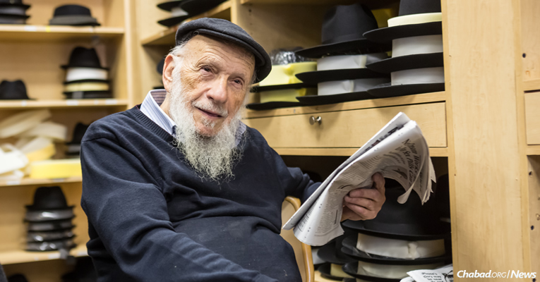
As 81-year-old Brooklyn-born Tzal Rotter remembers, authentic shmurah matzah was once a rarity. (Photo: Eliyahu Parypa/Chabad.org)

As 81-year-old Brooklyn-born Tzal Rotter remembers, authentic shmurah matzah was once a rarity.
At Primo Hatters, a block-and-a-half from the bakery in the Crown Heights neighborhood of Brooklyn, Rotter sits, the morning paper folded over his knee and a newsboy cap resting on his head at a jaunty angle. He grew up in the borough’s Brownsville neighborhood, at the time a lower-middle-class Jewish neighborhood packed with immigrants and their American-born children.
and Rotter and his siblings spent the weeks before Passover helping their father in the butcher shop, packing orders and delivering them at night.
“We had to take out the chicken pupiks [Yiddish for ‘gizzards’] without opening them up,” recalls Rotter. “Before Pesach, you had to do it very carefully—to clean it out so the chometz in the stomach didn’t get into the rest of the chicken.”
On the eve of Passover, after finishing up the final holiday meat and poultry orders, Rotter’s father would close up shop and the two of them would make the long trip to Manhattan’s Lower East Side, taking a bus over the Williamsburg Bridge to get to the Poilisher handmade matzah bakery, a mom-and-pop shop run by Chassidic Jews of Polish stock.

Packing up boxes of handmade shmurah matzah. (Photo: Eliyahu Parypa/Chabad.org)

“I remember it being the only matzah bakery around,” says Rotter. “It was in a tiny house with a storefront, and the bakery was downstairs in the basement.”
Carrying the box carefully by its twine string, they’d rush back to Brownsville with the round shmurah matzah, arriving home shortly before the holiday began. That evening, Rotter’s father would lead the seder with the special matzah.

“There weren’t many people who used shmurah matzah,” says Rotter. “My friends, they mostly had boxed machine matzah: Streit’s or Manischewitz or whatever.”
The sixth Rebbe—Rabbi Yosef Yitzchak Schneersohn, of righteous memory—had arrived in New York from war-torn Europe in 1940, re-establishing his yeshivah in America. Eight years later, in 1948, Rotter’s father transferred Tzal (short for Betzalel) to the Lubavitcher Yeshiva.
“That was the first time I saw shmurah widely used, when I came to Lubavitch,” he says. “I was 12.”

A Bakery of Their Own
Back in January 1950, two years after Rotter joined the Lubavitcher Yeshiva’s younger division, 20-year-old Rabbi Gedalya Korf arrived from Europe to join the older one. The Russian-born Korf had escaped from the Soviet Union together with his family in 1946, and after making it to a displaced persons camp in Germany, the family landed in Paris.

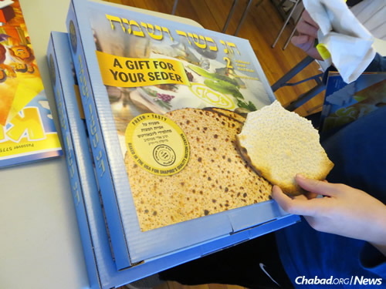
In 2017, more than 1 million pounds of the traditional round variety will be produced in the United States alone.

Korf reached New York at what proved to be a time of momentous change. Not long after disembarking Korf and a few fellow yeshivah students entered the sixth Rebbe’s office for a private audience, a day that turned out to be the last Sunday of the saintly rabbi’s life. R. Yosef Yitzchak passed away not a week later, on the 10th of the Jewish month of Shevat, which that year corresponded to Jan. 28. One year later, on the first anniversary of R. Yosef Yitzchak’s passing, his son-in-law, the Rebbe, formally accepted leadership of the Chabad movement.
Korf remembers only two shmurah matzah bakeries in operation at the time, both on the Lower East Side and catering to a small Orthodox clientele, primarily Chassidic Jews.
“The Rebbe Rayatz [a Hebrew acronym for R. Yosef Yitzchak] received his matzah from the Poilisher bakery,” recalls Korf. On the morning of the eve of Passover, a delegation of yeshivah students would take the subway to the bakery and personally prepare the sixth Rebbe’s matzahs.

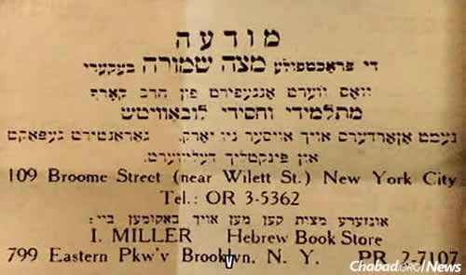
In 1954, Rabbi Yehoshua Korf, who passed away in 2007 at the age of 102, opened his shmurah matzah bakery at 109 Broome St. on Manhattan’s Lower East Side.

In 1953, Korf’s parents and siblings crossed the Atlantic to settle in New York. His father, Rabbi Yehoshua Korf, who passed away in 2007 at age 102, was born in Kremenchug, Ukraine, and educated in underground Chabad yeshivahs throughout the Soviet Union. (He served as director of the secret yeshivah in Kharkov in 1929, before it was closed due to pressure from authorities).
Not long after moving to New York, the elder Korf decided to open a business. According to his grandson, Rabbi Pesachya Korf, the elder Korf approached the Rebbe with a number of business ideas which the Rebbe advised against. When he informed the Rebbe that an opportunity had come up to open a bakery and asked whether that was the path for him, the Rebbe immediately gave his blessings. In 1954, Korf opened his shmurah matzah bakery at 109 Broome St. on Manhattan’s Lower East Side.
“I was more than involved” in helping to set up the bakery, recalls his son, Rabbi Gedalya Korf. Although it, too, was a small bakery, the younger Korf began implementing a number of innovations. He set the bakery up with distinct zones, starting with the room where the flour and water are mixed, followed by the rolling station, and lastly, the oven for the baking.
He also built separate rooms for the flour and water, each containing a window, with the mixing area situated between them. These innovations, which streamlined and simultaneously ensured a more kosher baking process, were subsequently adopted by other matzah bakeries and are today industry standards.
Although Korf’s shmurah matzah bakery was a private business, for Lubavitchers—many of whom had risked their lives in Soviet Russia for the sake of baking and consuming the ancient food of faith—it became a community institution. Finally, they had a matzah bakery of their own—one they did not have to keep hidden from persecuting authorities and prying neighbors, an American coming-of-age for a movement scarred by Russia.
Korf was a respected Chassid who throughout his long life served as a mentor within the Chabad community. After his bakery opened, Korf’s punctilious attention to halachic strictures quickly became widely known. According to Rabbi Pesachya Korf, the famed Rabbi Moshe Feinstein—one of the foremost halachic arbiters of the 20th century—insisted on purchasing his personal matzah from Korf’s bakery.
In the spring of 1954, not long after Korf’s bakery opened, the Rebbe began publicly speaking about the importance of distributing round, handmade shmurah matzah. Chabad emissaries, at the time still small in numbers but already widely scattered geographically, took the Rebbe’s words to heart and began handing out the crispy, irregularly shaped matzahs (since they are made by hand, each one comes out looking different, as opposed to the square machine type, which are uniform).
The Rebbe’s insistence that shmurah matzah be made available around the country emerged in curious ways. In one notable example, the Rebbe arranged that Chabad’s central educational organization, Merkos L’Inyonei Chinuch, pay for Korf’s shmurah matzah advertisements in Chicago through the Chabad emissary there at the time, Rabbi Shlomo Zalman Hecht.
The Lubavitch Matzah Bakery, now owned and operated by Rabbi Yitzchak Tenenbaum, moved to the Crown Heights in the late 1960s, and this year will have produced north of 100,000 pounds of matzah. Today, a half-century since opening as the first shmurah matzah bakery to look outside the confines of the Chassidic community, it continues its mission: supplying Jews of all backgrounds with the food of faith—the same round matzah their ancestors once ate.

Reprinted from the 2017 Pesach website of Chabad.Org First in a two-part series about the dramatic growth in the use of handmade shmurah matzah in the last 60 years.

The Warriors of Ephraim
By Nissan Mindel

More than a hundred years had passed since the death of Joseph in Egypt, and the bitterness of the Golut (Exile) had become daily more unbearable. The young prince, Moses, who was the first to protest against the Egyptian oppressors, had been forced to flee the country. For, Dathan and Abiram had reported to Pharaoh that the young Moses had killed an Egyptian Overseer who was beating up a Jewish slave.
At this time a certain Jew of the tribe of Ephraim appeared; his name was Yagnon. He addressed his fellow-Jews in a rousing battle-cry: "Listen, my brothers! A hundred and eighty years have already passed since our ancestors arrived in Egypt; we can wait no longer for salvation. We are strong enough to take this matter into our own hands to free ourselves from the Egyptian yoke and capture our land, the land promised to our forefathers!"
But the older men in his audience just shook their heads sadly, and said: "If Yagnon truly believes that G-d promised our forefathers the Land of Canaan, then why does he not also believe that G-d will free His people and give us our land when He judges it to be the right time?"
They armed themselves with swords, bows and arrows, and marched out of Egypt
Yagnon, despite his fiery, rousing words, had little success amongst the majority of his listeners. Only the men of his own tribe of Ephraim backed him up and tried to influence others to follow suit, but without avail.
Nevertheless, Yagnon and his followers were determined to act on their own. They armed themselves with swords, bows and arrows, and marched out of Egypt. A fierce battle ensued, and the warriors of Ephraim experienced their first victory.
Unfortunately, this was short-lived. They had brought no food with them, only gold and silver, meaning to buy food from the Philistines. The way to the Land of Israel through the Land of the Philistines was a short distance away, and the men of Ephraim soon found themselves at the borders of the Philistines. There, near the town of Gath, they saw herds of cattle and sheep and a number of shepherds taking care of them.
The men of Ephraim offered to buy some cattle and sheep, but the shepherds refused. However, the Ephraimites, tired and hungry after the heavy fighting they had gone through, began to round up some of the animals by force. The shepherds then set up a loud cry which brought out a large number of residents from the nearby city of Gath. A bitter battle followed, with heavy casualties on both sides. The men of Gath then sent out an urgent call for help throughout the land: "The Jews are threatening us and our land; Come and help us stop them!"
The Philistines quickly mobilized all their fighting men and hurried to the aid of Gath. The men of Ephraim saw that they were greatly outnumbered and, without G-d's help, they would be lost. They looked out over the valley of Gath and saw the great number of their men who had fallen in battle (whom the Philistines did not even allow to be taken away for burial) and whose bodies were fated to be left there, neglected and uncared for. (It was hundreds of years later that the prophet Ezekiel, through a Divine prophecy, brought the bones back to life in his prophecy about the Valley of the Dry Bones).
"Let us look forward to that great day when He will take us out of our Golut, with many wonderful miracles"
Very few of the men of Ephraim managed to save themselves. They escaped to Egypt and poured out their bitter feelings to their old father Ephraim, Joseph's son.
"I warned you, my dear children, that you should not depend upon your own powers, nor on the help of other nations," Ephraim said to his war-saddened sons. "But do not lose hope, my children! The time of salvation is not far off. Put your trust in G-d. He will surely fulfill the promise He made to our grandfather Jacob. Let us look forward to that great day when He will take us out of our Golut, with many wonderful miracles."
At that time Ephraim's youngest son was born whom he named Beriah, commemorating the misfortune (Ra'ah) that befell his tribe.
Thirty years later Ephraim's words became a reality. The Jews left Egypt under the leadership of Moshe Rabbenu, accompanied by the many miracles described in the Haggadah, which stir the hearts of all Jews, wherever they are, to this very day.

Reprinted from the JTF.ORG forum.

Story #1115
Seeking Elijah
After Two Seders
From the desk of Yerachmiel Tilles
editor@ascentofsafed.com

[I know this story has been circulating a lot lately on social media, but I have had it in my files since 2010. Also, the "punch line" is different from all other versions, -- YT]

It was in the weeks preceding Passover that one of the disciples of the Baal Shem Tov was overcome with a burning desire to see Eliyahu HaNavi [Elijah the Prophet]. The disciple knew that it would require much purity of mind and soul and that generally the Baal Shem Tov discouraged such endeavors.
However, the longing to have the great Prophet reveal himself was so intense that he couldn't distract his mind from the thought. After much deliberation and soul-searching, he decided to ask the Baal Shem Tov for his holy advice.
To the chasid's surprise, the Baal Shem Tov agreed to help him prepare himself for this life-transforming undertaking. The Baal Shem Tov gave the chasid an extensive list of spiritual preparations. Upon completing the list, the chasid reported back to the Baal Shem Tov, whereupon he was told to load a wagon with food, wine and matzas, and to travel to a nearby village where he was to spend the first two days of Passover with a certain family. There, surely, Elijah the Prophet would be revealed.
The chasid travelled to the village with mixed feelings of joy and trepidation. Would he truly merit to see the prophet? A little while later, the chasid arrived at the village and found the dilapidated hut of the impoverished family with whom he was meant to celebrate the two Seders and fulfill his heart's desire of seeing Elijah the Prophet.
"Shalom Aleichem - Peace to you" he announced to the man who answered the door. "I am a chasid of the Baal Shem Tov, and he sent me here to spend the two Seder nights of Passover with you. I've brought everything we will need for the holiday with me, enough food for your entire family and even new clothing for your children."
The man stood at the door dumb-founded. His wife came to the door and she, too, could not believe her eyes as she looked out at the overloaded wagon. The couple soon composed themselves and invited the traveler in.
The Seder night was unforgettable. The woman, her husband and their five children had never been in the presence of one of the Baal Shem Tov's holy pupils. They had never heard such rich Torah thoughts said in such clear and simple words that they could all easily understand. They had also never had such a royal feast at their Seder.
The chasid, for his part, did not forget even for one moment why he had come. At every stage of the Seder that first night, the chasid waited with eager anticipation for the Elijah the Prophet to appear.
They drank the four cups of wine, ate the traditional foods, explained each sentence of the Hagada with joy, sang the traditional holiday songs and even danced until the wee hours of the night. But Elijah did not reveal himself to the chasid.
At the second Seder, the same wondrous scene repeated itself for the family and their guest. The Torah insights, the joy, the food, the singing, the dancing. But this night, too, Elijah the Prophet did not appear to the chasid.
When three stars appeared in the sky the following evening, and the chasid had not merited to see Elijah the Prophet, he was heartbroken. He thanked the family for their hospitality and returned to the Baal Shem Tov.
During the journey back, the chasid wondered what had happened. Surely the Baal Shem Tov was not wrong when he had told the chasid that Elijah would reveal himself in that village family's home on Passover. Elijah must have been there and the chasid had somehow not merited to see him. Perhaps he had dozed off for an instant at the Seder without even realizing it and had missed seeing the Prophet.
When the chasid arrived at the Baal Shem Tov's court, he poured out his heart to his master. He repeated every detail of the past few days, waiting expectantly to hear how or why he had missed Elijah the Prophet.
The Baal Shem Tov thought for a moment and answered, "Go back to the village. Let your horse graze by the window of the house. There you will find your answer."
Without hesitation the chasid travelled back to the village. As he brought his horse to graze by the window of the home, he overheard a conversation between the husband and wife:
"What did you think of our guest?" the wife said to the husband.
"What do I think?" he replied "I think we should thank G-d and the holy Baal Shem Tov for sending us his chasid! The words of Torah, the beautiful explanations, the bountiful food. It was amazing!"
"That was no chasid," she interjected emphatically. "That was Elijah the prophet! I am absolutely sure that was Elijah the prophet."
Now the chasid understood. Elijah the Prophet employs many manifestations; fortunate is he who makes himself able to be one of them.

Source: Adapted by Yerachmiel Tilles from the rendition of Rabbi Tuvia Bolton, as published in L'Chaim Weekly #1017 (Pesach 5770-2010).
Biographic note: Rabbi Yisrael ben Eliezer (18 Elul 1698-6 Sivan 1760), the Baal Shem Tov ["master of the good Name"], a unique and seminal figure in Jewish history, revealed the Chassidic movement and his own identity as an exceptionally holy person, on his 36th birthday, 18 Elul 1734. He wrote no books, although many claim to contain his teachings. One available in English is the excellent annotated translation of Tzava'at Harivash, published by Kehos.

Reprinted from the April 29, 2019 email of Kabbalah Online, a project of Ascent of Safed.

How We Baked Matzah
In a Nazi Labor Camp
By Asharon Baltazar
Three men, all prisoners, could think of nothing but the imminent festival of Passover. As thousands of Jews—including their own relatives—were being sent to their deaths on a daily basis, Yaakov Friedman, Moshe Goldstein, and Rabbi Yekusiel Halberstam (the Klausenburger Rebbe) had the bravery and presence of mind to secure matzah for Passover 1945.
Here is Moshe Goldstein's account of the amazing turn of events that afforded them the ability to observe the Festival of Freedom amidst abysmal suffering and death:
In the days preceding Passover, the war was nearing its end. The relentless droning of American aircraft filled the German skies, followed by the whistling hail of bombs that pounded the Mühldorf railway complex into rubble.
Spared of destruction were the nearby forced labor camps where we toiled under the harshest conditions. We prisoners celebrated this mighty display of Allied destruction, but the anxiety of our German overseers ran high. The railway was vital to the war efforts, and orders were issued to immediately repair the damage. The Germans decided to send a group of 12 Jewish slaves to begin the cleanup.

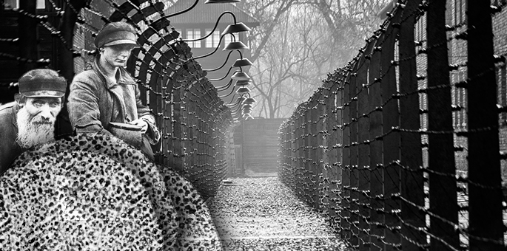

I knew the work would be excruciating but I hoped that perhaps I would find some food amidst the rubble.I volunteered to go. I knew the work would be excruciating but I hoped that perhaps I would find some food amidst the rubble.
We arrived at a scene of utter devastation. Freight cars lay on their sides, smoke rising from gaping holes. Stretches of railing were ripped off the ground and tossed aside in twisted heaps. Nearly every building suffered extensive damage. It was clear some of the cars were unrepairable.
I managed to disappear between the rows of trains that were still upright. It took a while, but I eventually found a boxcar from Hungary loaded with wheat in burlap sacks. Wheat! And so close to Pesach! G-d had granted us a good start, but how could I possibly smuggle the wheat into the camp?
A faint groan from amid the wheat sacks caught my attention. There, in a dark corner of the boxcar, lay a man, crushed by the enormous weight of the grain. The man mumbled something more, which I recognized as Hungarian, my native tongue. I saw he wore the gray uniform of an SS officer.
“What happened?” I asked.
The SS officer moaned weakly about being pinned under the sacks.
“I understand. Let me help you.”
As I approached, I noticed the officer’s boots, deep black in color and luxurious in appearance. On my own were bits of tattered leather, barely held together.
“I’m going to take off your shoes,” I said. “That way, you’ll feel less restrained, and then we’ll see what we can do.”
Once I had undone the laces, I slipped the heavy boots off. Then, wielding whatever strength and hate I could muster, I swung at the man’s head. I took the boots and continued my search.

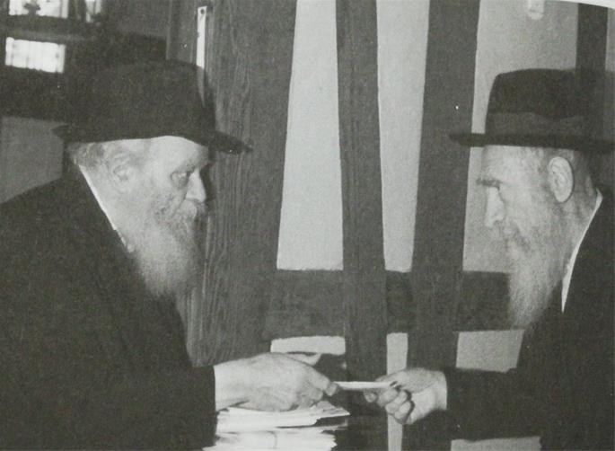
Reb Yaakov Friedman and the Lubavitcher Rebbe.

I knew I did not have much time and I needed to think of a way to bring in as much wheat as possible without the guards knowing. Lugging the sacks through the main gates didn’t even occur to me; the wheat would be confiscated and I would be shot without a second thought.
I rummaged around some more, and discovered two pairs of pants. I put them on and cinched the bottoms around my ankles with some rope. I was then able to pour a small quantity of wheat into the space between the two pairs of pants. Once my legs were filled with as much wheat as I dared carry, I began the long walk back to the camp.
The bombings left the Germans rattled and fearful, and for the initial days following the air raid, the inspection of prisoners at camp gates was enforced almost half-heartedly. I was thus able to smuggle in a fairly large amount of wheat.
We had wheat, but now what?
Reb Sender Direnfeld, a fellow inmate and a Belzer Chassid, offered to hide the wheat, and amazingly, he managed to keep it away from prying German eyes.
Later, an old mill was procured from somewhere. We ground the wheat in the dead of night, and using a clean piece of cloth, sifted the flour from grit.
Next we needed fuel for a fire.
During one stint in the field, I asked everyone to find a stick and carry it back to the camp. The branches were conspicuous and caught the attention of a German guard. He motioned me over.
“Why is everyone with a stick?”
“What difference does it make? People want to walk around with a stick,” I answered.
We had flour and we had fuel. We were ready to bake matzah.
One night just before Passover, we set about baking matzah. Near the barrack door stood a prisoner, standing guard with fearful eyes.
We lit a fire under a metal can which functioned as our oven, and the Matzah baking—under Nazi noses—began. The Rebbe, Reb Yaakov, and I mixed the flour and kneaded the dough. We worked quickly, not only because of the strict 18-minute limit, but also because of the ever-present danger of being caught. We ended up with 20 small matzahs.
On Pesach eve, after returning from work, our small group sat down for the Seder. On wooden slats around us lay sleeping bodies, exhausted from the relentless work. For those celebrating, the hardships of the Holocaust and daily camp life melted away as we experienced the Biblical redemption from Egypt. Unable to sit for long, we each ate an olive-sized piece of matzah, the taste of tears mingling with the matzah crumbs in our mouths.
We could not sit leisurely and recite the Haggadah, but in those moments we each prayed—more fervently than ever before or ever since—the words that still ring in my ears: “Next year in Jerusalem.”

Reprinted from the Parashat Tazria 5779 email of Chabad.org Adapted from Yaakov Friedman's memoirs, Tiferet Yaakov (Hebrew), written by his son-in-law, Rabbi Sholom Horowitz.

The Warsaw Watchmaker And the Tchebiner Rav

There was a tzaddik nistar, a watchmaker, who lived in Warsaw. The Tchebiner Rav wanted to get a brachah from him, so he broke his watch on purpose and brought it to this tzaddik’s shop to fix.
The tzaddik understood that he had purposely broken the watch to receive a brachah, so he said, “What do you want from me? I am a simple person?”
“So if not a brachah, at least tell me a dvar Torah.”
The tzaddik obliged. He said: The Rema (432:2) writes, “The custom is to place pieces of chametz for the one who is doing bedikas chametz so his brachah won’t be in vain.”
“The commentaries ask: How will placing pieces of bread help, since people know where the chametz is in their home? Is this called searching for chametz, when you know where all the pieces are? But we can bring a proof from the Torah that it is called searching.
“As it states (Bereishis 44:12), “[Yosef’s servants] searched [for Yosef’s goblet]. They began with the oldest [Reuven] and finished with the youngest [Binyamin] and they found…” Rashi writes that they knew the goblet was in Binyamin’s bag, but nevertheless they began their search with Reuven so it wouldn’t be obvious that they knew.
“We see from this pasuk that even when one knows where something is, it can still be searching. That is why even when one knows where the chametz is, it is still called searching for it.”
The Pnei Menachem of Gur added: Hashem placed the yetzer hara inside us. Just as we "search" and remove the chametz that we have ourselves placed, so Hashem will “search” and remove the yetzer hara from us which He placed in us.

Reprinted from the Pesach 5779 email of Torah Wellsprings: Collected Thoughts from Rabbi Elimelech Biderman

Stories of Stories
Of Tzaddikim

Rebbetzin Chavah Leah married the Chasam Sofer’s son, the Ksav Sofer zt’l. Her sisters-in-law (the Chasam Sofer’s daughters) told her about their father’s wondrous Seder. They told her that it is literally impossible to look at their father’s face at the Seder, because his countenance shone so brightly. Rebbetzin Chavah Leah didn’t believe them. At the Seder she tried to look at her father-in-law’s face, and she admitted that she couldn’t.
The Avnei Nezer said, “My father-in-law, the Rebbe of Kotzk, always appeared like a malach, but at the Seder, he appeared like a saraf (a greater form of angel)…. On the night of the Seder, the Rebbe of Kotzk was elevated beyond this world in a manner that we didn’t see by him, even on Yom Kippur…. At the second half of the Seder, sparks of fire sprouted from my holy father-in-law…"
Although our Seder will be very, very distant from theirs, these stories can inspire us to recognize the holiness of the night, and to invest effort to attain the potential that we can.

Reprinted from the Pesach 5779 email of Torah Wellsprings: Collected Thoughts from Rabbi Elimelech Biderman

Celebrating Passover as the Most Stringent, Not-Quite-Jew in Binghamton, N.Y.
By Ani Lipitz

“So, uh, when’s the lunar mission launching?”
My cousin stood in the entrance to my tiny kitchen, surveying the tinfoil-covered landscape with a raised eyebrow.
“Don’t come in here!!!” I shriek, leaping up from wrapping another layer of foil around the table legs to tackle her away from my precious chametz-free kitchen. “What did you have for breakfast?!”
“Wh ... what?”
“What did you have for breakfast?!”
“Uh ... um ... some eggs?” she stammers, clearly frightened for my sanity and her life.
“Any toast?!”
“Um ... n-no?”
“Don’t lie to me!”
“I d-didn’t eat toast!”

I stare at her for a good, hard second. Satisfied she’s telling the truth, I breathe a sigh of relief. “OK. Good.”
I leave her huddled on the couch as I return to my aluminum wrapping. “Sorry for the outburst,” I call casually. “Did you bring the goods?”
I hear a plastic bag rustling. “Can I come in there?” she asks timidly.
“Yes,” I say. “You’re cleared for entry.”
She reappears in the kitchen doorway and holds out the shopping bag. “They all have the ‘U’ with a circle around it and a ‘P’ next to it.”
I take the cans of tuna out of the bag to confirm their kosher-for-Passover status. “Excellent,” I say. “Thank you.”
“Um,” she says. “I have a question. Why does Rosie need to eat just tuna during Passover? Why can’t she eat regular cat food?”
“Because some of the regular brands of cat food is chametz,” I reply, shuddering at the word. “And I want to be extra careful because during Passover, we eradicate all chametzfrom our lives.”
“What’s kamits?” she asks. “I thought Jews just don’t eat bread during Passover.”
I roll my eyes. Typical. “Pretty much anything made from or processed with grain we don’t eat or have in our houses.”
“Oh,” she says. She looks around. “Where is Rosie, anyway?”
“Hiding somewhere,” I say. “I sprayed her down in the shower earlier to make sure she didn’t have any crumbs of anything on her.”
“Wow,” she shifts uncomfortably. “Don’t you think you’re getting a little, uh, intense about all this?”
I sigh, rolling my eyes again. “You wouldn’t understand,” I tell her, exasperated. “You’re not Jewish.”
“Well,” she says, “neither are you.”
Ouch.
It was true. All the foil-wrapping, cat-showering, cousin-tackling, frantic-Rabbi-calling craziness was just part of my pre-conversion education. But this was my first Pesach, and you bet I was going to be the most stringent and most religious not-quite-Jew in all of Binghamton, N.Y.!
“Don’t come in here!!!” I shriek
I didn’t bother explaining to my cousin the whole concept of a convert actually having a Jewish soul buried deep within them all along, but needing the conversion process to reveal that fact. I did, however, take the opportunity to glare scathingly at her and resume wrapping my table legs.
“All right,” she takes a step back. “I guess I’m gonna get going.”
“Thanks for the tuna,” I tell her.
“No problem,” she replies. “Have a happy Passover.”
“I’d rather have a perfectly kosher Passover,” I mumble as she heads out the door, slamming it shut at the last second to prevent a damp and traumatized Rosie from bolting after her to freedom.
I’m glad to report that my first Pesach did indeed go off without a halachic hitch. My apartment was probably cleaner for Passover than even the local Chabad House, and Rosie eventually forgave me for the shower when she realized she was getting to eat tuna for an entire week.
But I’m even gladder to report that now, as I approach my ninth Passover as an “official” Jew, my Passover experience has become just as happy as it is kosher. I realize My Passover experience has become just as happy as it is kosher that a lot of what I did that first Passover (including wrapping foil wrap on my table legs and not using kosher-for-Passover cat food) was not at all necessary. Granted, I still might break down and weep bitterly during pre-Passover cleaning, but that’s usually less about the stress of preparing and more about my pain at the thought of living without bagels for eight days.
Going chametz-free no longer feels like slave labor; it’s become part of the process of my personal exodus from Egypt. Every Pesach now, I celebrate not only my people’s past and future redemptions (may it be immediately!), but the redemption of my own soul. It was 21 years of bitter exile she suffered before G-d finally reached out with a strong arm and reminded her who she really is—a piece of Him, literally. And although I try my best to live with this knowledge every day, it’s during Passover that I feel the strongest connection to my G-dly self.
Chassidic teachings explain that this time of year, G-d’s infinite, unconditional love is pouring down on us, and all we have to do is work to clear ourselves of our personal chametz, our ego-based habits and thought patterns, in order to receive and internalize it.
So even when we start to count down the hours until that glorious, post-Passover slice of pizza, take a moment to revel in the opportunity you’re being given to connect with G-d and with your own soul.
Take a moment to revel in the fact that you are a Jew.

Reprinted from the Pesach 5779 email of Chabad.Org Magazine. Ani Lipitz is an educator and speaker whose passion is helping people integrate the teachings of Jewish mysticism into their daily lives. She lives in Pomona, NY, with her husband and children.

